

**A**

**PROJECT REPORT**

**ON**

**DESIGN AND IMPLEMENTATION OF A SMART HEALTH MONITORING SYSTEM FOR COMA PATIENTS**

**BY**

**AKINDIPE, BUKOLA ABIOLA**

**CPE/15/2385**

**SUBMITTED TO**

**THE DEPARTMENT OF COMPUTER ENGINEERING,**

**SCHOOL OF ENGINEERING AND ENGINEERING TECHNOLOGY,**

**FEDERAL UNIVERSITY OF TECHNOLOGY, AKURE**

**ONDO STATE, NIGERIA**

**IN PARTIAL FULFILMENT OF THE REQUIREMENTS FOR THE AWARD OF BACHELOR OF ENGINEERING (B.ENG) DEGREE IN COMPUTER ENGINEERING**

**SEPTEMBER, 2021**

# 

# CERTIFICATION

This is to certify that this project was carried out and the report written by me **AKINDIPE BUKOLA ABIOLA** with Matriculation Number **CPE/15/2385** of the Department of Computer Engineering, The Federal University of Technology, Akure, Ondo State, Nigeria in partial fulfilment of requirements for the award of Bachelor of Engineering (B.Eng.) degree in Computer Engineering.

------------------------------------ ------------------------------------

Student’s Signature and Date External Supervisor

Signature and Date

------------------------------------ ------------------------------------

Prof. Y.O. Olasoji (Supervisor) Prof. E.O. Ogunti (HOD)

Signature and Date Signature and Date

# 

# DEDICATION

I hereby dedicate this project work to God Almighty for the overwhelming love, mercies, favour, grace and benefits He lavished on me throughout my academic pursuit in this great citadel of learning.

# ACKNOWLEDGEMENT

Ultimate thanks go to my Heavenly Father and God, for sustaining, protecting and preserving me all through the years of my study. Without Him, I would not have been able to overcome all the challenges and hurdles faced during this journey, but in Him alone I found triumphant and euphoric victory.

I’m sincerely grateful to my supervisor, Prof. Y.O. Olasoji, for his fatherly advice, encouragement, guidance, and correction which facilitated the successful completion of this project. His words of wisdom and motivational talks gave me the courage and strength to pursue and accomplish this project research successfully. He selflessly gave his time and expertise to patiently attend to all of my inquiries for the purpose of this study and also to help me improve practically in the field of electronics. I will also not fail to appreciate Mr Tony for his support and contributions towards the success of this project.

I also appreciate the former Head of Department, Dr (Mrs) F.M. Fadahunsi and the current Head of Department Prof. E.O. Ogunti for their overwhelming love and indefatigable efforts at ensuring that students make records of success and excellence academically, skilfully and morally.

Finally, I want to celebrate and appreciate my parents, Mr. A.I. Akindipe and Mrs. J.I. Akindipe for their unrelenting love and support in all ramifications that facilitated the successful completion of this project. I’m also thankful to my siblings, Akindipe Akinjisola and Akindipe Funmilola for the love and care showered on me and also for their effective words of encouragements.

# ABSTRACT

The fact that health is acknowledged as one of the fundamental rights of persons may be used to gauge the importance of health care in society. There are several IoT trends that have developed for our safety. Wearable, Surgical Robotics, AI, AR, ML, and Big Data Integration with IoT.

This project, Smart health Monitoring System for Comatose Patients, is a functioning framework that incorporates sensors to monitor body temperature, pulse rate, and movements. A microcontroller board analyses the patient's inputs, and any irregularity detected by the patient triggers an alarm from the monitoring system.

The system is beneficial in reducing the burden of a manual requirement to continuously monitor the comatose along with assistance to the doctor about the health and consciousness status of the comatose remotely through the use of a web application. It alerts the doctor of any abnormal conditions in the vitals of the comatose or movement changes of the comatose. Also in the emergency cases, the doctor is able to monitor the patient’s condition efficiently to reduce time consumption, thus it provides more effective healthcare system. So due to importance of patient monitoring system, the continuous monitoring of the coma patient can be simplified.

# TABLE OF CONTENTS

Page

CERTIFICATION ii

DEDICATION iii

ACKNOWLEDGEMENT iv

ABSTRACT v

TABLE OF CONTENTS vi

LIST OF FIGURES x

LIST OF TABLES xi

LIST OF ABBREVIATIONS xii

CHAPTER ONE 1

INTRODUCTION 1

1.1 Background of Study 1

1.2 Motivation 4

1.3 Aim of the Project 4

1.4 Objectives of the Project 4

CHAPTER TWO 6

LITERATURE REVIEW 6

2.1 Machine Learning and IoT Based Smart Health 9

2.2 IoT Based Patient Monitoring 12

2.3 Real-time location and patient monitoring system based on passive RFID. 12

2.4 ECG (Electrocardiograph) 13

2.4.1 ECG sensor generated within the body 14

2.4.2 Heart Beat 15

2.5 ARDUINO 17

2.6 Communication between Hardware and Software 17

CHAPTER THREE 18

METHODOLOGY 18

3.2.1 Software Used: 20

3.2.2 Circuit Components 21

3.3 Hardware Implementation 21

3.3.1 The System Circuitry 22

3.4 WEB SERVER 23

3.4.2 CSS 25

3.4.3 HTML 25

3.5 COMPONENTS USED 25

3.5.1 ESP32 MICROCONTROLLER 26

3.5.2 MAX30100 Pulse Oximeter Sensor 26

3.5.3 DS18B20 Temperature Sensor 27

3.5.4 DHT11 Humidity & Temperature Sensor 28

3.5.5 Flex Sensors 29

3.5.6 Buzzer 30

3.5.7 Power Supply Unit 31

3.6 LCD (Liquid Crystal Display) 32

RESULTS AND DISCUSSIONS 34

4.0 Preamble 34

4.2 DEVELOPMENT ENVIRONMENT 34

4.3 Graphical User Interface 35

4.3.1 Web Page Login 35

4.3.2 Patient’s Vital Monitoring Page 36

4.3.3 LIQUID CRYSTAL DISPLAY (LCD) 37

4.4 Operating Mechanism 38

4.5 SYSTEM FUNCTIONALITY TEST CASES 38

4.6 PERFORMANCE TEST 39

5.1 CONCLUSION 41

5.2 RECOMMENDATION 41

REFERENCES 43

# 

# LIST OF FIGURES

Figure Title Page

Figure 2.1: Normal sinus rhythm ECG 14

Figure 2.2: Heart Diagram 15

Figure 3.1: Architecture of the Smart Health Monitoring System 18

Figure 3.3: Flow chart of the Smart Health Monitoring System 20

Figure 3.2: Block diagram of the Smart Health Monitoring System 20

Figure 3.4: The schematic diagram of the health monitoring system 22

Figure 3.5: Implementation of the Transmitter Circuit on Breadboard 23

Figure 3.6: Webserver and client HTTP Communication 24

Figure 3.7: ESP32 microcontroller 26

Figure 3.8: Max30102 27

Figure 3.9: Wired DS18B20 28

Figure 3.10: DHT11 28

Figure 3.11: Flex Sensor 29

Figure 3.12: Flex Sensor Circuit 30

Figure 3.13: Buzzer 31

Figure 3.14: Power supply circuit simulation. 32

Figure 3.15: LCD displaying the vitals 33

Figure 4.1: Development Environment 35

Figure 4.2: Webpage Login 36

Figure 4.3: Patient’s Vital Monitoring Page 37

Figure 4.4: The designed system 38

# LIST OF TABLES

Table Title Page

Table 2.1: Rate of heartbeat per minute 16

TABLE 4.1: System functionality test cases 39

TABLE 4.2: Sensor Data Readings Collected 40

# LIST OF ABBREVIATIONS

VS: Vegetative State

MCS: Minimally Conscious State

NODEMCU: Node Microcontroller Unit

Wi-Fi: Wireless Fidelity

GCS: Glasgow coma scale

CO2: Carbon dioxide

ECG: Electrocardiograph

LCD: Liquid Crystal Display

BPM: Beats per Minute

IDE: Integrated Development Environment

LED: Light Emitting Diode

**VCC: Voltage Common Collector**

**GPIO: General Purpose Input/Output**

HTML: Hypertext Markup Language

CSS: Cascading Style Sheet

XHTML: Extensible Hypertext Markup Language

RF: Radio Frequency

DC: Direct Current

IC: Integrated Circuit

CAD: Computer Aided Design

# CHAPTER ONE

# INTRODUCTION

## Background of Study

Healthcare is one of the global challenges for humanity. According to the constitutions of the World Health Organization (WHO) the highest attainable standard of health is a fundamental right for an individual. To keep individuals healthy, an effective and readily accessible modern healthcare system is a prerequisite. A modernized healthcare system should provide better healthcare services to people at any time and from anywhere in an economic and patient friendly manner. According to Shivleela and Dr. Sanjay (2018) in traditional method, doctors play an important role in health check-up because this process requires a lot of time for registration, appointment, and check-up and then reports are generated later. Due to this lengthy working process people tend to ignore the check-ups or postpone it. According to Sathya, Madhan and Jayanthi (2018), the increased rate of medically challenged people has made remote healthcare become a part of our life.

According to Naveen and Hardeep (2011), Coma is sometimes called persistent vegetative state and is a profound or deep state of unconsciousness, in which a person cannot be awakened; fails to respond normally to painful stimuli, light, sound, lacks a normal wake-sleep cycle and does not initiate voluntary actions. Coma is different from sleep because the person is unable to wake up. It is also not the same as brain death because the person is alive, but they cannot respond in the normal way to their environment.

There are numerous causes of medical coma. Some of them are focal processes, in which there are localised abnormalities that exist only in one part of the brain. Focal processes include haemorrhagic strokes, ischaemic strokes, brain tumour and infections in the brain. Other causes are traumatic head injury, drug or alcohol intoxication, or even an underlying illness, such as diabetes or an infection (Edith O, Kayode-Iyasere, Austine O, Obasohan, 2018).

During a coma, a person cannot communicate, so diagnosis is through the outward signs which include but not limited to closed eyes, limbs that do not respond or voluntarily move except for reflex movements, lack of response to painful stimuli except for reflex movements. How long these will take to develop, and how long they will continue, depend on the underlying cause.

Before entering a coma, a person with worsening hypoglycaemia (low blood sugar), or hypercapnia (higher blood CO2 levels), for example, will first experience mild agitation. Without treatment, their ability to think clearly will gradually decrease. Finally, they will lose consciousness. If a coma results from a severe injury to the brain or a subarachnoid haemorrhage, symptoms may appear suddenly.

Glasgow coma scale (GCS) is the device that is used to test the severity of coma. Based on the GCS reading, a coma is classified into two phases namely; Persistent vegetative state (VS) and minimally conscious state (MCS).

 In a retrospective review of the medical records of all comatose adult patients, admitted between January 2014 and December 2016 at the Central Hospital Benin, ninety patients presented in coma within the 3-year period under review and this constituted 1.7% of all medical admissions. There were 49 (54.4%) males and 41 (45.6%) females with a mean age of 64.6 ±17.0 years. The Glasgow coma score ranged from 3 – 8. The commonest cause of coma was stroke (57.9%), followed by metabolic and toxic causes (23.3%) and central nervous system infections (11.1%). The main presenting complains were sudden collapse (85.6%) and fever (31.6%). The most predisposing co-morbid conditions were hypertension (71.1%) and diabetes mellitus (24.4%).

Coma is a common cause of admission in the emergency unit, medical wards and intensive care unit. It accounts for significant morbidity and mortality (Edith O, Kayode-Iyasere, Austine O, Obasohan, 2018). Approximately 5% of the patients presenting to the Emergency Department and 1% of the admissions at the Emergency Department are due to coma (Edith O, Kayode-Iyasere, Austine O, Obasohan, 2018). Most patients with severe traumatic brain injuries in developing countries are discharged to home-based care due to a lack of rehabilitation facilities and health insurance.

The care needed for the improvement in the health of a comatose is substantial when compared to any other in-house patients. Usually, there is a caretaker along with the coma patient to fulfil the needs required by them. But in most cases, the family opts to attend to the needs of the patients by themselves. In such cases, if there are any emergencies, the doctor is called upon for the treatment which is time- consuming and dangerous. Moreover, there is a loss of interest for the patient's family to monitor the patient 24/7. Hearing from VS to MCS is rare and the caretaker or even the experts are habitually unaware of when the change will happen. Usually the comatose does not respond to any external stimuli. In such a case, the approach manner by close ones towards the comatose may either be a healthy or harmful impact on a patient's recovery. The harmful approach should be kept as minimum as possible to speed up the healing of comatose.

The proposed solution serves best to overcome the disadvantages described beforehand. Firstly, it provides complete monitoring of the vitals of the comatose i.e., temperature, heart rate, BP, etc. These factors are monitored continuously and if it crosses the thresholds provided then a quick message is sent to the doctors into the mobile app. The doctors can read the vitals and relate the previous values of the vitals which are stored in the database. Finally, the transition from the vegetative state to the minimally conscious state is caught by the eye movement (blink) as well as the movement of the fingers and is announced to the patient's doctor through the buzzer and notification. The time of recovery is also noted for future study reference.

## Motivation

With the development of the world, Health monitoring system for comatose is used in every field such as hospital, home care unit, sports.

There are various instruments available in market to keep track on internal body changes. But there are many limits in maintenance part due to their heavy cost and size of instrument. Different biomedical sensors like temperature sensor, heart rate sensor, blood pressure sensor are used for monitoring the vital health conditions which is integrated on single system on-chip as well as motion detection sensors such as eye blink and flux sensor used to detect movements or changes in the physical body of the patient. If any varied change takes place, it is notified. This notification would help to take an appropriate action at an instance of a time. This would save patients from the future health problem. This would also help patient's concern doctor to take an appropriate action at proper time.

## Aim of the Project

The aim of this project is to develop an IoT based system that continuously monitors a comatose patient.

## Objectives of the Project

During the course of the study, the following specific objectives are expected to meet:

1. To build a real-time wearable device that continually monitors the vitals of a comatose patient such as body temperature, blood pressure, pulse rate etc.
2. To build a real-time wearable device that captures the transition states of the comatose patient and immediately sends response to the clinician via a web/mobile app and buzzer.
3. To unify all wireless sensors connected to the wearable device to a Wi-Fi module and embed with a microcontroller board.
4. To develop a web/mobile application interface to receive and display the data from the electrical sensors connected to the wearable devices.
5. To properly implement the system to provide timely warnings to the medical staffs and doctors and their service can be activated in case of medical emergencies

# CHAPTER TWO

# LITERATURE REVIEW

Wireless sensor networks (WSN) are now being used in health care to track heart problems, breathing problems, panic reactions, and stress levels. Despite the fact that many studies focus on technical, financial, and social concerns, technological sprints must be handled in order to have a WSN that is dependable, secure, adaptable, and power-efficient. In specialized areas, the integration of existing medical equipment with wireless networks is likely to happen shortly. Small, nonintrusive wearable sensors will make it easier to capture huge amounts of data automatically. This will minimize the number of visits to clinics and, as a result, the cost. (2019, Swaroop, Chandu, and Gorrepotu). Future study in this subject will help the whole medical community. Different sensors can be integrated into the wearable and at the same time gather bio-signals in an unobtrusive and non-invasive way. The emerging technology for communication in healthcare is by mobile monitoring systems. Self-management of patients was possible with a phone call and SMS. This method produced satisfactory changes in patient self-efficacy, adherence to treatment and behavioural changes. A clinically validated and flexible framework, performing real-time analysis of physiological data to monitor patient health conditions has also been developed. Data mining techniques are used for analysing the data collected by sensors. Real-time processing was performed, and alerts triggered in critical situations. In a unique approach to measure the heart rate by a non-contact and non-invasive device, a CCD (charged coupled device) camera was employed in a trial of 14 Asian participants. Airstrip Technologies developed using AppPoint software platform, a new monitoring system that can be as good as smart phones and personal computers. According to Topol, acceptance of mobile phones in healthcare is possible because of ever-growing use of smart phones, enhanced bandwidth with third and fourth generation (3G and 4G) mobile data networks and computing power comparable to that of a personal laptop computer. There is a competitive market of medical technology using information technology for healthcare provision. Healthcare systems are advancing for cloud adoption and artificial intelligence driven analytics for diagnosis. A system for prediction and support for aged individuals suffering from memory impairment was implemented using information from unimpaired cases. IoT research is clearly geared towards engaging cloud technologies with evolutionary computing tools to deliver urgent or monitored medical assistance. Integrating different modes of communication for health monitoring would help to overcome drawbacks in communication. BLE (Bluetooth low energy) can be exploited for short-range transmission, Wi-Fi over the Internet and SMS when the Internet is inaccessible. (Swaroop et al. 2019). Now-a-days increasing of technologies health experts is taking the great advantage of these electronic gadgets. IoT (Internet of things) devices are highly used in medical sector. In this paper, the project is about health monitoring system especially for coma patients. In rural area because in rural area number of doctors is less than urban area. In rural area, medical equipment is not available except government hospital. So, the number of patients is higher than government hospital. Also, the equipment is expired in many cases. So, if any emergency call needed, this hardware device will immediately send the report to the doctors or intern doctors. Doctors will do their rest of works by their reports. But in present time, no remote HRV (Heart Rate Variability) analysis systems for coma patients is available to help the doctors to track down the progression of the patient's condition or critical events in rural area. IoT is nothing but an advanced concept of ICT (Information Communication Technology). Raspberry pi component is more costly than Arduino component device. Technologies are broadly expanded in web based or on line system. Now- a - days collecting real time is vital. When a patient with a critical condition is discharged from the hospital, he or she needs to be checked up on a regular basis. That is why IoT based heath monitoring system is best option for rural area. The Internet of Things digitizes physical assets – sensors, devices, machines, gateways and the network. It connects people to things and things to things in real time. A typical IoT network can grow rapidly, resulting in an experimental increase in the variety, velocity and the overall volume of data. These data opens opportunities for significant value creation and revenue generation. But the real challenge for IoT environments is how to analyse the large volume of information from all sources and take action in real time. The complexity of IoT combined with the high expectations created by the Internet, Mobile, and 24x7 IT environments has made the need for new analytics approaches and technologies more urgent. Achieving desired business objectives requires the ability to act in real-time to take advantage of opportunities and address problems quickly. In the pre-IoT era, an issue in a typical supply chain scenario could be addressed in 2-3 day cycles for satisfactory results. But in IoT, time to action is in minutes, seconds, or microseconds – 30 minutes to provision electric service, 30 seconds to act on information from devices, 5 milliseconds to address a security breach. This explosion of data and the high expectations in the IoT environment means the value of data will slip away quickly. The importance of time-to-action for IoT applications can be seen in a wide array of applications and use cases. Broadly speaking, these applications can be grouped into three categories:

1. Operations and fulfilment are a convenient place to prove out efficiency gains.
2. Customer-focused sales and marketing applications have the potential to increase customer satisfaction and long-term growth.
3. Innovation in new products and services can drive new revenue and business value. There are also specific use cases within these applications:
4. Predictive Maintenance
5. Demand/Supply Optimization.
6. Predictive 1 to 1 Marketing
7. Outage Management Addressing the critical time-to-action requirement for these use cases and applications in IoT demands an advanced analytics solution that
8. Unifies historical, real-time streaming, predictive, and prescriptive analytics.
9. Provides faster analytics and smarter actions. (Israt, Navid, Reza, Mahbub 2018).

## Machine Learning and IoT Based Smart Health

The human body is constantly providing information about one’s state of health. This information is obtained through systems or devices that measure capture or detect values and variables at specific points of the body in an invasive or non-invasive manner. Healthcare personnel use the values of biomedical variables to make decisions on diagnoses and treatments in order to improve patients’ health. The IoT makes it possible to interconnect, detect, identify, and process data between objects or services to fulfil a common objective. The main advantages of IoT in healthcare are the monitoring, analysis, diagnosis, and control of conditions and the generation of recommendations to prevent them. However, the objects used in the IoT have limited resources, so it is necessary to consider other alternatives for data analysis, such as machine learning. Machine learning is a subset of artificial intelligence that consists in studying the algorithms and statistical models used in computer systems in order to achieve specific objectives effectively, based on patterns and inferences. At present, there are several challenges in the health sector that provide areas of opportunity for the IoT and machine learning to provide solutions or alternatives that contribute to improving healthcare and quality of life. (Machorro-Cano, Alor-Hernández, Paredes-Valverde, Ramos-Deonati, Sánchez-Cervantes and Rodríguez-Mazahua, 2019). Most healthcare institutions rely on conventional information systems that are difficult to implement due to the inability to meet the demands of end-users. Hence, legacy information systems do not conform to recent developments in ICT. Technological advances can better deal with operational problems in healthcare delivery with the application of computational tools to hospital activities. In a healthcare system, ICT provides health services to anyone at any time and any location. ICT advances enable patients, who are remotely located, to perform their routine activities in a daily basis. In a modern health care, technological advances can better deal with operational issues, such as physician and patient relationship improvement , easy access to and sharing of information among medical care units and people who are close to patients (e.g., relatives), high mobility for uninterrupted monitoring of patients‟ health status not limited to hospital facilities, involvement of external health care professionals in treatment and diagnosis of patients, emergency situation alerts to health care professionals, and so on. Wearable biomedical sensors are very useful due to the need for monitoring of vital signs, patients‟ activities, and real-time health parameters, and without hindering their movements. Vital signs differ based on patients‟ activities, smoking, sleeping habits, temperature, and others. If heart rate increases while a patient sleep, it is recognized as an abnormal case. While conventional health care assistant (HCA) systems are standalone applications that rely on local devices and servers, they are not flexible in monitoring different patients with distinctive health issues. There are several user roles involved in the remote care platform; they are mainly the nursing staff, agent servers, physicians, platform administrators, patients, sensors, and foreign care.

* Agent Server: to ensure the system operates automatically, the agent server allows the message to automatically flow to the correct object, such as the monitoring of comatose patients, in which the guidelines can be set in advance. Thus, when the patient regains consciousness, the agent server sends a notification informing the physician or caregiver.
* Nursing staff: They frequently contact physicians and discuss appropriate medical intervention and referral, regular follow-up, and try to understand the changes in the disease, while also handle inspection reports, clinical plans, and other treatment stages. In addition, nursing staff conduct monitoring and tracking through telephone interviews. Moreover, they play a crucial role in distant care in the form of frequent contact with patients, as well as the tracking of personal health records.
* Physician: in abnormal physiological information, physicians along with nurses discuss and consult other relevant medical treatments to take appropriate intervention measures with the inclusion of the personal follow-up records of patients.
* Platform Administrator: is responsible for operating the platform, including abnormal message monitoring, network monitoring, software deployment, hardware sensor management, and data transmission.
* Patient: patients receive medical treatment with the use of a sensing device that helps measure blood pressure and pulses through an Electrocardiogram Sensor (ECG).
* Sensor: an instrument collecting the patients’ physiological data, which refers to a blood pressure monitor or thermometer. The sensor transmits the data to the nearby data receiving station through the wireless communication pipe at a fixed time.
* Foreign care: they are responsible for the first-line contact with patients. Hence, through foreign care, patients are trained to wear the sensing devices in a correct way to ensure the system is connected, runs smoothly, and can receive the alert signal in the emergency. (Su, Hajiyev and Fu, 2019)

## IoT Based Patient Monitoring

According to Israt et al. (2018), 4.9 million people died from lungs cancer, overweight 2.6 million, 4.4 million for elevated cholesterol, and 7.1 million for high blood pressure. Patients who need a regular monitoring by doctors to discuss the state of health condition, IoT based patient Monitoring system is useful for them. The main concept of IoT is defined as the integration with electronic devices that connect with doctors or health monitoring persons. IoT the term was first mentioned by Kevin Ashtor in 1998. IoT can be divided in three sections.

1. Internet – Oriented Middle ware.
2. Things Sensors Oriented.
3. Knowledge Oriented Semantics.

First as hardware layer which allow the interconnection by using sensors and technologies. Sensors are used to measure Heart Beat, ECG, and Temperature etc. The main purpose of this IoT is to improve a solution based on ontology with ability to monitor the health status.

## Real-time location and patient monitoring system based on passive RFID (P. Najera, J. Lopez, and R. Roman, 2011).

This study is about the literature on RFID applications in healthcare based on a formal research framework. We aim to identify opportunities, potential benefits and adoption barriers. Our study shows that most health care providers indicated that RFID to be functional and it should be useful in tracking and patient identification. Major barriers to RFID adoption in healthcare include prohibitive costs, technical limitations, and privacy issues. Although RFID offers advantages in healthcare to enhance clinical practice, better designed RFID systems are needed to increase ac

## ECG (Electrocardiograph)

ECG or Electrocardiography is a system which can record and measure the electrical activity of the heart over a period of time using electrodes on the skin. Bio monitoring electrodes have passed through a great evolution and progress from 19th century. In 1883, Carlo Matteucci who was a professor of physics at the University of Pisa, first time showed and proposed sensors that watch and monitor the electricity in human body periodically. In 1887, Augustus D.Waller was presented and published the first human electrocardiogram. He was British physiologist. In 1901, Willem Einthoven made re infrastructure of Waller’s technology. Here, he used fine quartz coated with silver in a device which is called the string galvanometer. Einthoven won noble prize for formulate and create the electrocardiograph. In present time, bio monitoring electrodes use in ECG which is made of a plastic substrate covered with a silver chloride ionic compound. The Ag/Acl electrode is mostly used for all the application in bio medical electrode system. These electrodes create an electrical potential and ionic activity in living cells. After connecting the human body, these potentials are demonstrate on the body surface.

The heart starts activation at sino-atrical node which is build and produces heart frequency about 70 cycles per minute. This activation generated to the right and left muscle tissues. There is delay which use to allow the ventricles to fill with blood from atrial contraction in the ventricular node. These activities help to pump blood to the aorta and to the rest of the body. At last, the repolarization happens and the cycle is repeated time after time. When the cycle take place, the trans membrane potential which measure the voltage difference between the internal and external spaces of the cell membrane create a changes at the each stages. Voltages differences are measured by using the surface electrodes. These different peaks P, Q, R, S, T and U are detected in these stages.

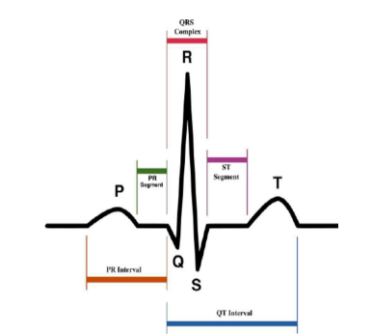

**Figure 2.1: Normal sinus rhythm ECG (**Israt Jarin Hoque, Md.Shadman Navid, Rifat Binte Reza, Mashwab Ibna Mahbub, IoT based patient monitoring system 2018).

### ECG sensor generated within the body

The heart has four chambers. The upper two chambers (left/right atria) are section focuses into the heart, while the lower two chambers (left/right ventricles) are shrinkage chambers sending blood through the course. The dissemination is splitted into a "circle" through the lungs (aspiratory) and another "circle" through the body (foundational). The cardiovascular cycle alludes to an entire pulse from its age to the start of the following beat, containing a few phases of filling and purging of the chambers. The frequency of the cardiac cycle is reflected as heart rate (beats per minute, bpm). The heart works naturally – it is self-energizing (different muscles in the body require anxious jolts for excitation). The rhythm of compressions of the heart happen unexpectedly, yet are touchy to apprehensive or hormonal impacts, especially to thoughtful (stimulating) and parasympathetic (decelerating) air conditioning activity.

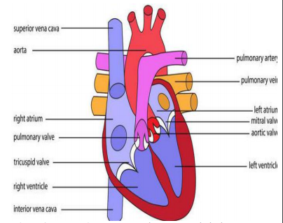

**Figure 2.2: Heart Diagram (**Israt Jarin Hoque, Md.Shadman Navid, Rifat Binte Reza, Mashwab Ibna Mahbub, IoT based patient monitoring system 2018).

### Heart Beat

Heart rate known as pulse rate is the number of times a person’s heart beat per minute. Normal heart rate varies from person to person but a normal range for adults is 60 to 100 beats per minute. Also normal heart rate depends on the individual age, body size, and heart condition also if the person is sitting or moving, medication use and even air temperature. Emotion can vary heart rate for example getting excited or scared can increase the heart rate. According to American Heart Association (AHA) well trained athlete may have a normal heart rate of 40 to 60 beats per minute. There are 4 steps to measure heart rate:

1. Wrist
2. Inside of an elbow
3. Side of the neck
4. Top of the foot

How to measure accurate heart rate: Put two fingers over one of these areas and count the number of beats in 60 seconds. Also measure 20 seconds and multiply by three which is easier than first step.

Resting heart rate: When a person is in resting mode, it is the best time to measure heartbeat. According (AHA) for adults and older normal heart rate is between 60 and 100 beats per minute (bpm). But below 60 (bpm) doesn’t mean the person has health issue problem. Active people have lower heart rates because their muscles don’t need to work as hard to maintain a steady beat.

Maximum and target heart rate: A person’s target heart rate zone is between 50 percent and 85 percent of his or her maximum heart rate. According to (AHA) 30 year old person would be between 50 and 85 percent of his or her max heart rate.

Table 2.1: Rate of heartbeat per minute

|  |  |  |
| --- | --- | --- |
| **Age** | **Target HR Zone 50-85%** | **Average Maximum Heart Rate 100%** |
| 20 years | 100-170 bpm (Beats per minute) | 200 bpm |
| 30 years | 95-162 bpm | 190 bpm |
| 35 years | 93-157 bpm | 185 bpm |
| 40 years | 90-153 bpm | 180 bpm |
| 45 years | 88-149 bpm | 175 bpm |
| 50 years | 85-145 bpm | 170 bpm |
| 55 years | 83-140 bpm | 165 bpm |
| 60 years | 80-136 bpm | 160 bpm |
| 65 years | 78-132 bpm | 155 bpm |
| 70 years | 75-128 bpm | 150 bpm |

## ARDUINO

Arduino provides open source electronics prototyping platforms based on flexible, easy to use hardware and software. It is a microcontroller development board based on the Atmel ATmega 328 MCU. The Arduino UNO has 14 digital input or output pins (of which 6 can be used as PWM outputs), 6 analog inputs, 16 mega Hz crystal oscillator, a USB connection, a power jack, ICSP header and a reset button. This Arduino MCU board contains everything needed to support the microcontroller. Simply connected to a computer with a USB connection, power it with an AC to DC adaptor or battery to get started. The Arduino UNO differs from all preceding boards in that it does not serial convertor. The Arduino UNO MCU board can be powered via the USB connection or with an external power supply. The power source is selected automatically.

## Communication between Hardware and Software

In this project, communication between hardware and software in serial data communication is used. Serial data communication uses two methods. 1. Synchronous 2. Asynchronous In where, synchronous method transfers a block of data at a time. Asynchronous method transfers a single byte at a time. It is possible to write software to use either of the methods. The program can be tedious and long that’s why special IC (integrated circuit) chips is made by many manufactures for serial data communication. These chips are commonly referred to as Universal Asynchronous Transmitter / Receiver (UART).

# CHAPTER THREE

# METHODOLOGY

**3.0 Introduction**

This chapter gives a design of the health monitoring system segments. The system comprises of two main segments: the health monitoring system and a web application for remote accessibility.

**3.1 System Architecture**

This project has been developed with ESP32 microcontroller connected with sensors which are attached to the patient. Figure 3.1 shows the general overview of the system operation. All the sensors real time readings are sent from microcontroller, and can be accessed via HTTP request from the webpage to the domain name service (DNS). A doctor or guardian can log in to web portal to monitor patient’s data at any point in time and able to take necessary actions in case of emergencies.

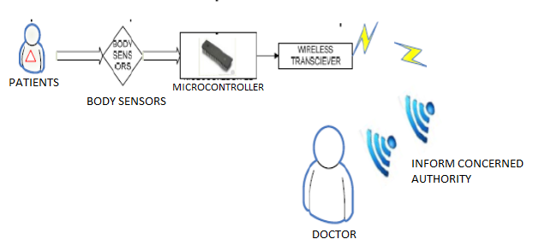

Figure 3.1: Architecture of the Smart Health Monitoring System

**3.2 Comatose Monitoring System**

There are two parts engaged to implement the proposed system, the hardware, and software. The ESP32, buzzer, LCD, DHT11, DS1 Receiver are the hardware requirement of the system. Arduino IDE was used for the programming. Fig. 3.2 shows the block diagram of the system.

This device uses an ESP32 web server to track patient health of the monitoring system wirelessly. Patient health parameters such as body temperature, heart rate (BPM), blood oxygen levels (Sp02) as well as room temperature and humidity can be monitored from any device like Smartphone, PC, Laptop, and Smart TV that support browsing capabilities.

The blood Oxygen Concentration termed as SpO2 is measured in Percentage and Heart Beat/Pulse Rate is measured in BPM using the MAX30100 which is both a Pulse Oximetry and a heart rate monitor sensor.

Patients need to be kept in a room with standard temperature and humidity level so as not to make them feel uncomfortable. Hence, DHT22 sensor was used to get temperature and humidity readings.

The readings are displayed on an LCD and the data are also sent to the web app wirelessly for doctors to monitor and keep track of.

**Micro controller**

Wireless Connection

Room Temperature

Flex Sensors

Web Application

Heart Beat Sensor

LCD

Body Temperature

Buzzer

Power Supply

|  |
| --- |
| The system flow chart can be represented as shown in Figure 3.3.  NO  START  Initialize (Sensors)  Web Applications  Turn ON Alarm System  YES  Sensor Readings  Sensor Readings>  Threshold? |
| Figure 3.3: Flow chart of the Smart Health Monitoring System |

Figure 3.2: Block diagram of the Smart Health Monitoring System

### 3.2.1 Software Used:

Software technologies used in the project are as follows:

* Arduino IDE
* Visual Studio code
* JavaScript
* HTML
* CSS

### 3.2.2 Circuit Components

The basic components and instruments used for the implementation of the comatose health monitoring system are:

* Power Supply (12v Adapter, 9V Battery)
* DS18B20
* DHT11
* MAX30102
* FLEX SENSORS
* Transistor (BC337 (X2))
* Capacitors (10uF (X3), 100uF (X2), 0.1uF (X2), 47uF,)
* Resistors (330kΩ, 100kΩ, 2.2kΩ, 220Ω, 100kΩ (X2), 100Ω, 10kΩ (X2), 1kΩ (X3))
* Voltage Regulator (7809)
* LED

## 3.3 Hardware Implementation

After knowing the background studies, theories and literatures of this project, the designing of the system to be implemented is to be done. Designing of the system, includes designing of the schematic diagram, choosing the right components to be used, choosing the right value of components to be used, and implementation of the schematic diagram both on software and hardware, and testing the reliability and effectiveness of the system.

The schematic diagram was initially implemented using Proteus software, where the circuitry was developed and adjusted until the desired output was gotten. This was subsequently implemented on breadboard using the corresponding values of the components from the software.

### 3.3.1 The System Circuitry

The schematic diagram in Figure 3.4 shows the health monitoring circuitry powered using a 2200 mAh 3.7 V Lipo battery.

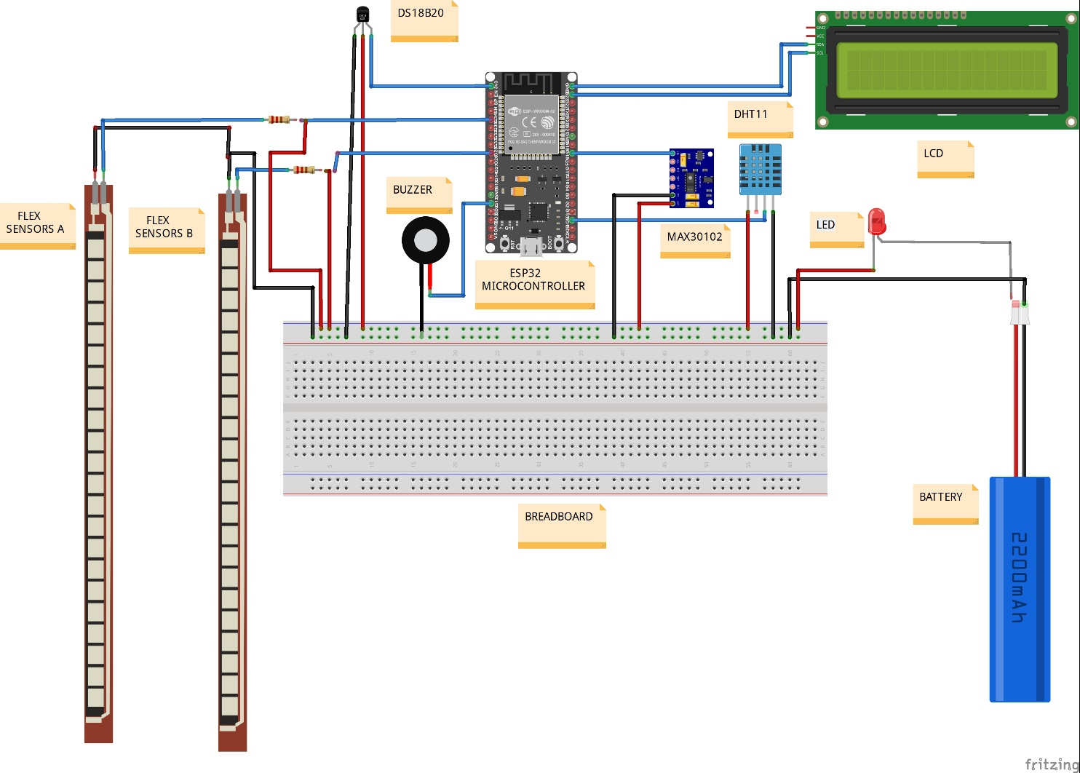

Figure 3.4: The schematic diagram of the health monitoring system

ESP32 Micro controller is connected with all the sensors. All the sensor can work at **3.7V VCC**. The flex sensors are connected to **GPIO34 and GPIO35 respectively through a voltage divider resistor of 4.7k ohms.** MAX30100 which is an I2C Sensor is connected to SDA & SCL pin of the microcontroller. The output pin of DHT11 is connected to **GPIO18** pin of the ESP32. Similarly, output pin of DS18B20 is connected to **GPIO5** of ESP32. A 4.7K pull-up resistor is connected between output pin & VCC pin of DS18B20.

A buzzer is connected to ESP32 at GPIO38 which is used in case any of the sensor data thresholds are exceeded. LCD is connected to micro controller GPIO39 and GPIO40 pins to display sensor readings.

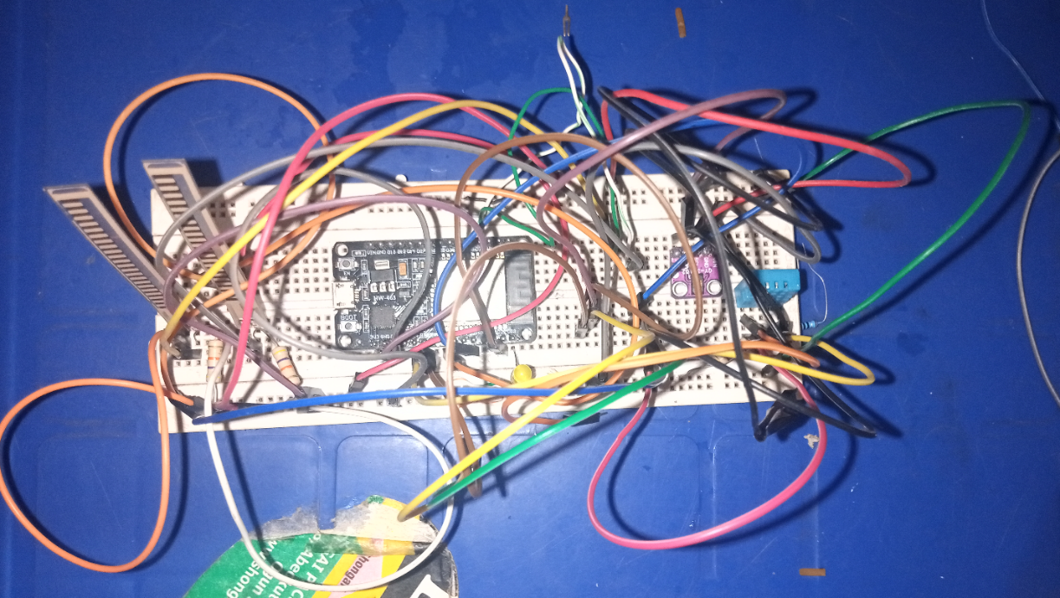

Figure 3.5: Implementation of the Transmitter Circuit on Breadboard

Figure 3.7 shows the connection of the system circuit on breadboard. Both horizontal rows at the top and bottom of the breadboard were used for power supply (positive and ground). The circuit was supplied with a stable 3.7V dc power supply.

## 3.4 WEB SERVER

The Web Server is a combination of hardware and software responsible for maintaining, fetching and serving web pages to Web Clients. The web server is mobile responsive and can be accessed with any device that as a browser connected to the same Wi-Fi network as ESP32. The webpage was designed using HTML, CSS and JavaScript.

Hyper Text Transfer Protocol or simply HTTP is the protocol responsible for communication between Client and Server. In this type of communication, the Web Client makes a request for information from the server using HTTP. The Web Server, which is always waiting (listening) for a request, responds to the client’s request with appropriate web page. If the requested page is not found, then the server responds with HTTP 404 Error. Figure 3.8 provides a view of client-server based communication.

The ESP32 is used as a host for storing web pages, and the sensor readings are updated regularly as the web browser on the device, sends a request for that web page over HTTP, the web server in ESP32 responds with the web page.

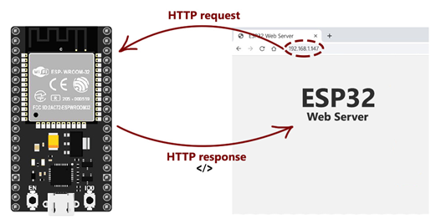

Figure 3.6: Webserver and client HTTP Communication

**3.4.1 JavaScript (Vanilla)**

JavaScript is the world's most popular programming language. It is the programming language of the Web. It allows one to implement complex features on web pages, introducing dynamism; displaying timely content updates, interactive maps, animated 2D/3D graphics, scrolling video jukeboxes rather than static contents. (Firefox, 2021b)

### 3.4.2 CSS

Cascading Style Sheets (CSS) is a style sheet language used for describing the presentation of a document written in a mark-up language (Firefox, 2021a). It was used to set the visual style of the web pages and user interfaces written in HTML and XHTML, and is applicable to rendering in speech, or on other media. Along with HTML and JavaScript, CSS is a cornerstone technology used by most websites to create visually engaging webpages, user interfaces for web applications, and user interfaces for many mobile applications.

CSS is designed primarily to enable the separation of document content from document presentation, including aspects such as the layout, colors, and fonts. This separation can improve content accessibility, provide more flexibility and control in the specification of presentation characteristics, enable multiple HTML pages to share formatting by specifying the relevant CSS in a separate .CSS file, and reduce complexity and repetition in the structural content.

### 3.4.3 HTML

HyperText Markup Language (HTML) is seen as the skeleton that gives every webpage structure. In this course, we used HTML to add paragraphs, headings, images and links to the webpages.

## 3.5 COMPONENTS USED

The major hardware components used in designing the system are discussed.

### ****3.5.1 ESP32 MICROCONTROLLER****

ESP32 is a low-cost, low-power system on a chip (SoC) series with Wi-Fi & dual-mode Bluetooth capabilities! The ESP32 family includes the chips ESP32-D0WDQ6 (and ESP32-D0WD), ESP32-D2WD, ESP32-S0WD, and the system in package (SiP) ESP32-PICO-D4. At its heart, there's a dual-core or single-core Tensilica Xtensa LX6 microprocessor with a clock rate of up to 240 MHz. ESP32 is highly integrated with built-in antenna switches, RF balun, power amplifier, low-noise receive amplifier, filters, and power management modules. Engineered for mobile devices, wearable electronics, and IoT applications, ESP32 achieves ultra-low power consumption through power saving features including fine resolution clock gating, multiple power modes, and dynamic power scaling

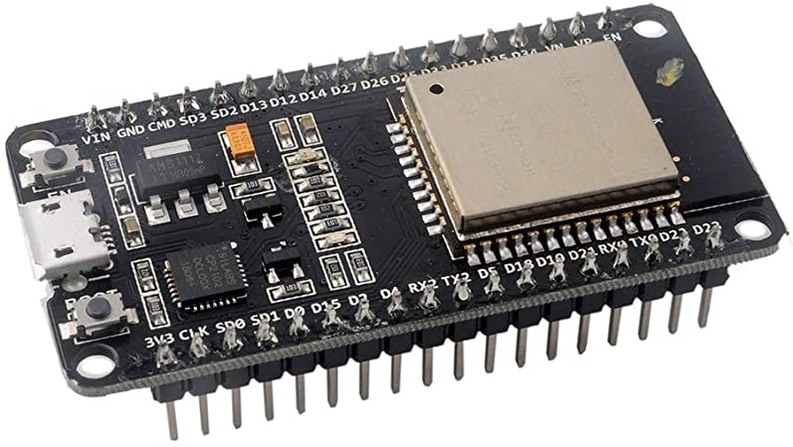

Figure 3.7: ESP32 microcontroller

### ****3.5.2 MAX30100 Pulse Oximeter Sensor****

The sensor is integrated pulse oximetry and heart-rate monitor sensor solution. It combines two LED’s, a photodetector, optimized optics, and low-noise analogue signal processing to detect pulse and heart-rate signals. It operates from 1.8V and 3.3V power supplies and can be powered down through software with negligible standby current, permitting the power supply to remain connected at all times.

The device has two LEDs, one emitting red light, another emitting infrared light. For pulse rate, only the infrared light is needed. Both the red light and infrared light is used to measure oxygen levels in the blood. When the heart pumps blood, there is an increase in oxygenated blood as a result of having more blood. As the heart relaxes, the volume of oxygenated blood also decreases. By knowing the time between the increase and decrease of oxygenated blood, the pulse rate is determined.

It turns out, oxygenated blood absorbs more infrared light and passes more red light while deoxygenated blood absorbs red light and passes more infrared light. It reads the absorption levels for both light sources and stored them in a buffer that can be read via I2C

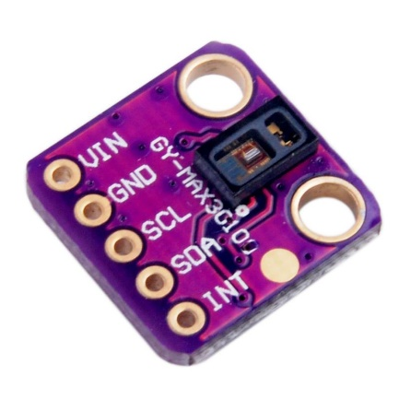

Figure 3.8: Max30102

### ****3.5.3 DS18B20 Temperature Sensor****

The Sensor can measure the temperature between **-55 to 125°C** (-67°F to +257°F). The cable is jacketed in PVC.

The sensor does not have signal degradation even over long distances because it is digital. It is a 1-wire digital temperature sensors which is fairly precise, i.e **±0.5°C** over much of the range. It can give up to 12 bits of precision from the onboard digital-to-analog converter. A 4.7k pull up resistor is used from the DATA to the VCC line when using the sensor.

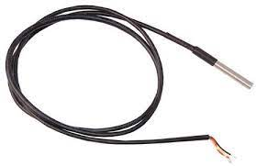

Figure 3.9: Wired DS18B20

### ****3.5.4 DHT11 Humidity & Temperature Sensor****

**DHT11** uses a capacitive **humidity sensor** and a **thermistor** to measure the surrounding air, and spits out a digital signal on the data pin (no analog input pins needed).

It’s fairly simple to use and requires careful timing to grab data.

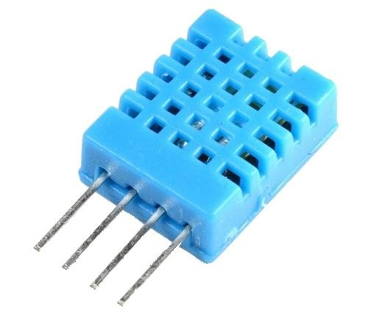

Figure 3.10: DHT11

### 3.5.5 Flex Sensors

A flex sensor is basically a variable resistor that varies in resistance upon bending. Since the resistance is directly proportional to the amount of bending, it is often called a **Flexible Potentiometer**. The Flex sensor used is about 2.2″ (5.588cm) long.

A flex sensor consists of a phenolic resin substrate with conductive ink deposited. A segmented conductor is placed on top to form a flexible potentiometer in which resistance changes upon deflection. Flex sensors are designed to flex in only one direction – away from ink (as shown in the figure). Bending the sensor in another direction may damage it.

When the sensor is bent, conductive layer is stretched, resulting in reduced cross section (imagine stretching a rubber band). This reduced cross section results in an increased resistance. At 90° angle, this resistance is about 100KΩ. When the sensor is straightened again, the resistance returns to its original value. By measuring the resistance, you can determine how much the sensor is bent.

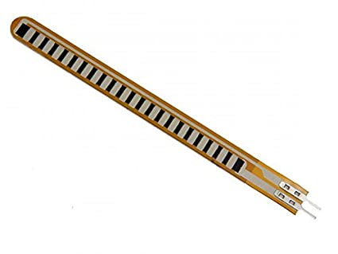

Figure 3.11: Flex Sensor

The easiest way to read the flex sensor is to connect it with a fixed value resistor (usually 47kΩ) to create a voltage divider as shown in Figure 3.14. One end of the sensor is connected to power and the other to a pull-down resistor. Then the point between the fixed value pull-down resistor and the flex sensor is connected to the ADC input of an Arduino.

This way a variable voltage output is created, which can be read by microcontroller ADC input.

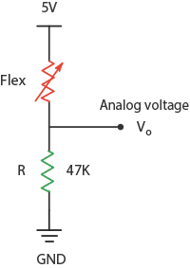

Figure 3.12: Flex Sensor Circuit

### 3.5.6 Buzzer

A buzzer (shown in Fig. 3.15) is a tiny speaker. Applying an electric signal at the right frequency will make it produce sound. This will be used to signal people in the form of tone or beep. To alert the people within the vicinity.

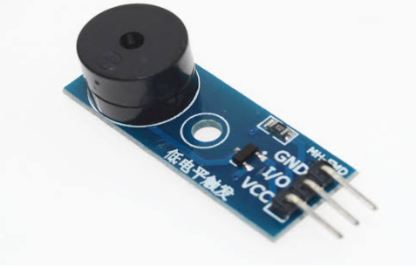

Figure 3.13: Buzzer

### 3.5.7 Power Supply Unit

9 V DC battery was used as the main source of power for the system. Since microcontrollers make use of 5 V for optimum operation. The DC power source had to be stepped down to a stable 5 V DC source using the LM7805 regulator. It consists of three pins.

* INPUT: In this pin of the IC positive unregulated voltage is given in regulation.
* GROUND: In this pin where the ground is given. This pin is neutral for equally the input and output.
* OUTPUT: The output of the regulated 5V volt is taken out at this pin of the IC regulator.

LM7805 regulator has Input voltage range of 7V- 35V, a Current rating collector current (Ic) of 100mA and an Output voltage range of to 4.8V to 5.2V.

Figure 3.16 shows the result of the circuit simulation. The circuit diagram for the regulated 5 V DC supply was designed and tested using CAD software Proteus, a switch was also put to ON and OFF the supply.



Figure 3.14: Power supply circuit simulation.

## LCD (Liquid Crystal Display)

A liquid-crystal display (LCD) is a [flat-panel display](https://en.wikipedia.org/wiki/Flat_panel_display) or other [electronically modulated optical device](https://en.wikipedia.org/wiki/Electro-optic_modulator) that uses the light-modulating properties of [liquid crystals](https://en.wikipedia.org/wiki/Liquid_crystal) combined with [polarizers](https://en.wikipedia.org/wiki/Polarizer). Liquid crystals do not emit light directly instead using a [backlight](https://en.wikipedia.org/wiki/Backlight) or [reflector](https://en.wikipedia.org/wiki/Reflector_(photography)) to produce images in color or [monochrome](https://en.wikipedia.org/wiki/Monochrome). LCDs are used in a wide range of applications, including [LCD televisions](https://en.wikipedia.org/wiki/LCD_television), [computer monitors](https://en.wikipedia.org/wiki/Computer_monitor), [instrument panels](https://en.wikipedia.org/wiki/Dashboard), [aircraft cockpit displays](https://en.wikipedia.org/wiki/Flight_instruments), and indoor and outdoor signage. There are several types of LCD based on dimensions.

The serial UART 16×2 LCD allows control to a parallel based LCD  
over a single-wire serial interface. The serial LCD takes care of all the HD44780 commands allowing seamless integration with any micro that can communicate over a wide range of TTL serial baud rates. The Communication with Serial 16×2 LCD requires 5V TTL serial at a default baud rate of 9600bps (8-N-1). The baud can be adjusted to any standard rate between 2400 and 38400bps. The power, ground and RX pins are all broken out to a 4-pin 2.54mm pitch header.

Serial 16×2 LCD shown in Figure 3.15 has the ability to dim the backlight to conserve power if needed. There is also a potentiometer on the backpack to adjust the contrast.

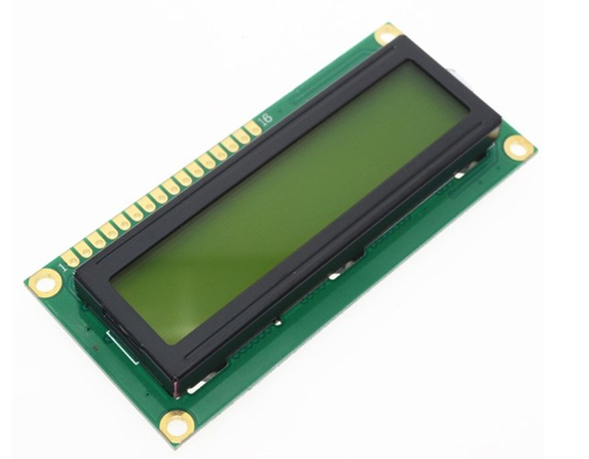

Figure 3.15: LCD display

**CHAPTER FOUR**

# RESULTS AND DISCUSSIONS



## 4.0 Preamble

This chapter explains all the phases of implementations carried out to achieve the functionalities, effectiveness and the efficiency of the designed system.

**4.1 SYSTEM (PROTOTYPE) IMPLEMENTATION**

The prototype implementation is the last step which comes after a thorough analysis of the various sections explained in chapter three. At this stage, the component values specified in the analysis of each were used to realize the section in the breadboard according to the circuit diagram presented. A system prototype implementation involves interfacing the entire hardware components together in the breadboard after carrying out the software burning. After the development of the prototype, it was then functionally tested. The circuit was implement on a Vero board to get the finished product for the complete system.

## 4.2 DEVELOPMENT ENVIRONMENT

The webpage was development using visual studio IDE to write the HTML and CSS codes. The webpage was made responsive and less heavy to enhance the loading speed.

The health monitoring system code was written in C programming using Arduino IDE. The code debugged using the serial monitor. After the code upload to the microcontroller, the serial is opened to read the microcontroller internal operations. Figure 4.1 shows the output from the Arduino serial monitor after code upload. The IP address of the ESP 32 sever is extracted from there, and inputted into a browser to display the readings.

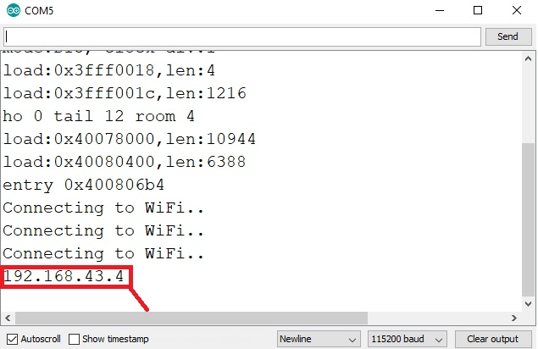

Figure 4.1: Development Environment

## 4.3 Graphical User Interface

This Project is designed to make sure that user interface pages are easily understandable and the navigation between pages is obvious. Below is a list of web pages that user can navigate between and are shown in details.

### 4.3.1 Web Page Login

Here doctor or care taker enter patient’s unique credentials. Once the credentials are verified, login page will be navigated to Patient vital monitoring page where doctor or caretaker can view current vital readings of the patient. Here patient’s unique credentials must be kept confidential by the doctor and caretaker to protect privacy of the patient data.

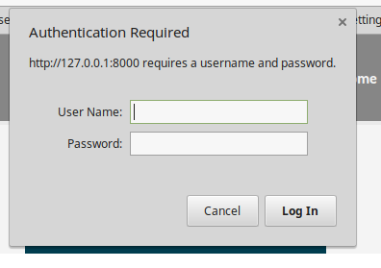

Figure 4.2: Webpage Login

### 4.3.2 Patient’s Vital Monitoring Page

After doctor or care taker login successfully, either can able to view live patient’s vital information which includes temperature, humidity, and heartbeat, of the patient. The output is displayed in the form of string in a particular interval of time. The application is very simple as it just displays the analog values followed by a statement describing the kind of value displayed.

The current readings of the patient are displayed on patient vital monitoring page without any error. In case device is not connected or any of the sensor is not attached to patient, then all the readings or respective reading would be shown as zero in case of digital values.

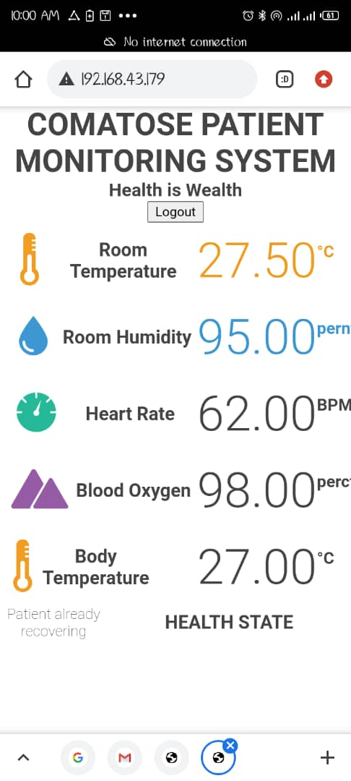

Figure 4.3: Patient’s Vital Monitoring Page

### 4.3.3 LIQUID CRYSTAL DISPLAY (LCD)

General on-site users have access to the patient’s medical readings via the LCD. It displays the patient’s Temperature, oxygen (O2) level and the heart beat readings as shown in Figure 4.4.

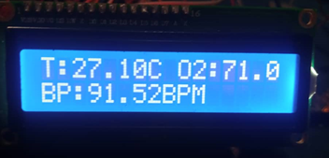

Figure 4.4: Patient’s health readings displayed on LCD

## 4.4 Operating Mechanism

The sensors are attached to the patient’s finger and body. The heart beat sensor contains an IR sensor in it. For every pulse pump from the sensor, its output is given to the microcontroller via signal conditioning unit for amplification. Figure 4.4 shows the implemented system.

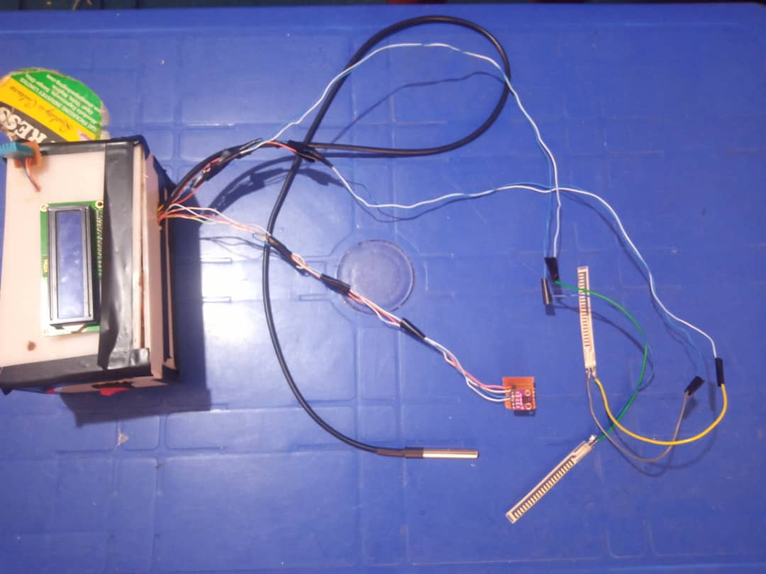

Figure 4.5: The designed system

## 4.5 SYSTEM FUNCTIONALITY TEST CASES

A test case is a set of test data, preconditions, expected results and post conditions, developed for a test scenario to verify compliance against a specific requirement. I have designed and executed a few test cases to check if the project meets the functional requirements.

TABLE 4.1: System functionality test cases

**Test Objectives:** Navigation from Web server booting, Login page to Monitoring page

|  |  |  |  |  |
| --- | --- | --- | --- | --- |
| **S/N** | **TEST CONDITION** | **INPUT SPECIFICATION** | **OUTPUT SPECIFICATION** | **PASS/FAIL** |
| 1 | Web Server Running | Turn on WIFI | Client connects to the DNS. | **PASS** |
| 2 | The user is currently on the login page | User enters credentials and clicks on login button | Directs to monitoring page | PASS |
| 3 | The user is currently on the Monitoring page | Page auto-refresh | Get updated Readings | PASS |

## 4.6 PERFORMANCE TEST

To validate the efficiency of the system, it was used on different patients and compared with standard instruments. For this, a sample of 5 people of different age and health status were engaged to check their health conditions using the system developed.

The results of the satisfaction survey can be seen in Table 4.2.

TABLE 4.2: Sensor Data Readings Collected

|  |  |  |  |  |
| --- | --- | --- | --- | --- |
| **PATIENT NO** | **TEMPERATURE (C)** | | **HEART BEATS (BPM)** | |
| **MEASURED** | **ACTUAL** | **MEASURED** | **ACTUAL** |
| 1 | 36 | 36 | 110 | 111 |
| 2 | 32 | 31 | 90 | 93 |
| 3 | 35 | 36 | 120 | 118 |
| 4 | 39 | 39 | 118 | 118 |
| 5 | 37 | 37 | 80 | 82 |
| **Total** | **179** | **179** | **518** | **522** |

From the table above, it is seen that the temperature reading have an accuracy of 100% and the heartbeat has an error rate of 0.77%.

**CHAPTER 5**

**CONCLUSION AND RECOMMENDATION**

## 5.1 CONCLUSION

The project provides low-cost solution to enhance the remote monitoring capability of existing health care system by using web server. The system can wirelessly monitor vital signs of patients in real-time and medical personnel can respond as the case warrants. The sensor readings can be accessed from any device with browser. If the obtained current values exceed the threshold value an alarm system is triggered and the response is displayed on the webpage.

This system is helpful for patients who need healthcare services at 24/7. By using this method where the doctor can check his patient anywhere, anytime. It uses three sensors such as IR Pulse rate, Body temperature monitoring. The sensors are operated and vital information is transmitted to the microcontroller.

The hardware for the project is implemented and the output results are verified successfully. The system can be installed for testing the health parameters of patient’s in their home for health care monitoring and the wireless sensor network can operate on an area of 6-10 square meters.

## 5.2 RECOMMENDATION

This System can be enhanced to detect and collect data of several anomalies for monitoring purpose such as home ultrasound, Brain signal monitoring, Tumour detection etc. The interface can be designed to control which sensors can be used by consumers according to their needs.

Web UI can be enhanced to perform several activities which include controlling the hardware, real-time graphs, history and analysis graphs to observe anomalies etc. Tackle Distributed denial of service. DDOS, and Data privacy/security especially of medical systems.

# REFERENCES

Arun K P. Aswin Suresh., & Jibin M T. Jithin C, (2018). Comatose Patient Monitoring

System using Neural Oscillation and Mind Wave, International Journal of Engineering

Research & Technology (IJERT) ISSN: 2278-0181, www.ijert.org RTICCT

B. Praveen Kumar, & K. Mahendrakan, (2014). Prevention of Accident Due To Drowsy by Using Eye Blink in International Journal of Innovative Research in Science, Engineering and Technology Vol. 3, Issue 5, ISSN: 2319-8753

Emna, M., Ernesto, E., & Khalil, D. (2017). A Model-Driven Methodology for the Design of Autonomic and Cognitive IoT-Based Systems: Application to Healthcare, IEEE transactions on emerging topics in computational Intelligence, vol. 1, no. 9.

Geethanjali R., Fathima K. M., Harini S., Sabitha M. (2019). Health monitoring for coma patients, International Journal of Emerging Research & Development, vol. 2, Issue 3.

Josphine, M., Hamsageetha, P., Monisha, P., & Yuvarani, S. (2018). Body Movement and Heart Beat Monitoring For Coma Patient Using IoT, International Journal of Innovative Research in Science, Engineering and Technology, Vol. 7, Special Issue 2.

Kayode-Iyasere EO, Obasohan AO, & Odiase FE. (2019). Medical coma in a secondary health centre in Benin City, Nigeria: A 3-year review. Port Harcourt Med J; 13:58-62

Kanich W, Brady W.J, Huff J.S, Perron A.D, Holstege C, Lindbeck G, *et al.* (2002). Altered mental status: Evaluation and etiology in the ED. Am J Emerg Med;20:613-7.

Koganti, S., Suma, H., Appaji, M. (2015). Abhishek Analysis and Monitoring of Coma Patients using Wearable Motion Sensor System, International Journal of Science and Research (IJSR), Volume 4 Issue 9.

Lukeman O.F, Datti M.A, Geoffrey O, Yusuf AM, Musbau R, & Shakira OD. (2012). Etiology and outcome of medical coma in a tertiary hospital in North Western Nigeria. Ann Niger Med; 6:92-7.

M. Sathya, S. Madhan, & K. Jayanthi. (2018). Internet of things (IoT) based health monitoring system and challenges International Journal of Engineering &Technology, 7 (1.7) 175-178 International Journal of Engineering & Technology Website: www.sciencepubco.com/index.php/IJET Research paper

Molugu Surya V, Bindu S M, Aishwarya B, Dhanush B N, & Manjunath R ounte, (2018). Security and privacy challenges in the Internet of Things. Proceedings of the 2nd International Conference on Trends in Electronics and Informatics (ICOEI), IEEE Conference Record: # 42666; IEEE Xplore ISBN: 978-1-5386 3570-4

Naveen Kansal, Hardeep O. & Singh Dhillon. (2011) Advanced Coma Patient Monitoring System International Journal of Scientific & Engineering Research Volume 2, Issue 6, June-2011 1 ISSN 2229-5518 IJSER <http://www.ijser.org>

Rahul P. Deshmukh, & Prof. A.R.Wadhekar (2016), Smart sensors techniques to monitor comatose patients using embedded system.

Sandeep, S., Esther, R, & Sumalatha, G. (2018). Monitoring of Health Parameters by Using Raspberry Pi, International Journals of Advanced Research in Computer Science and Software Engineering, vol. 7, Issue-4.

Shivleela Patil, & Dr. Sanjay Pardeshi, (2015). Health monitoring system using IoT International Research Journal of Engineering and Technology (IRJET) e-ISSN: 2395-0056 Volume: 05 Issue: 04 | Apr-2018 www.irjet.net p-ISSN: 2395-0072

Stanley J. Swierzewski MD 3rd. 9 (2015) Health Communities. Com/Coma/causes.

Suliman M Fati, Amgad M, Dheeraj C. Mungur, & Ahmad B (2018). Integrated Health Monitoring System using GSM and IoT, International Conference on Smart Computing and Electronic Enterprise. (ICSCEE).

Unnikrishnan.C, & Ramesh.P, (2017). Early warning of Brain death in Hypoglycemic Coma using FPGA based Wearable device. International Conference on Innovations in information Embedded and Communication Systems (ICIIECS)

Y Ichimaru, H Tanaka, K Hirata, & S. Katayama, (1994). Central Regulation of l/f

Fluctuations of Heart Rate Variability in Patients with Coma, 0276- 6547/94 $4.00

# https://developer.mozilla.org/en-US/docs/Learn/

https://www.medicalnewstoday.com/articles/173655#symptoms